**Assignment for Manual Tester Role**

**Instructions:**

1. App should be written using **Plain JavaScript & HTML** - no third-party libraries like KineticJS or jQuery should be used.
2. The Assignment is divided into two modules, and both carry equal weightage.
3. Once both the modules are done, you can add any new features to the same.
4. **Upload the solution to Google-Drive or OneDrive** & mail the link to jobs@canvasjs.com with Email Subject “**Solution: Bubbles App - Testing**”. Please use the EXACT Email Subject mentioned.
5. **Do not copy from other sources or do not post solutions online (like GitHub, JSFiddle, Codepen, etc.) - if we get multiple answers with similar code, all of them will be rejected.**

**Note:**

**Module 1** and **Module 2** should be implemented in the same application and not in two different files.

**Module 1:**

1. Create a Simple Application using **HTML5 Canvas Element**. Draw a circle to the left side of the canvas & fill it with random color.
2. Draw an arrow corresponding to the circle to the right side of the canvas.
3. **The circle & the arrow should be drawn on a single canvas element.**

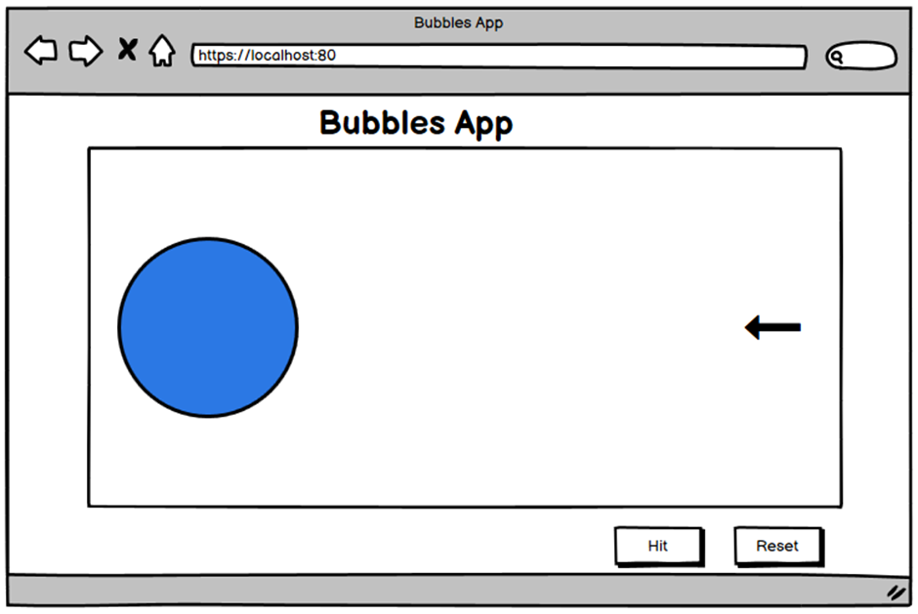

**Module 2:**

1. Add a Hit button. When you click on the Hit button, the arrow should start moving towards the circle & hit it.
2. Color of the circle should change once the arrow hits it.
3. Add a reset button that resets the application to its initial state.

